Terna Engineering College
Computer Engineering Department
Program: Sem VI

Course: Cloud Computing Lab (CSL603)

Faculty: PREETI PATIL
Experiment No.4
A.1 Aim:
To study and Implement Platform as a Service using AWS Elastic Beanstalk/ Microsoft Azure App Service.
A.2 Prerequisite:
Understanding of Virtualization,Basics of Networking ,Basics of security and privacy.

A.3 Objective:
To demonstrate the steps to deploy Web applications or Web services written in different languages on AWS Elastic Beanstalk/ Microsoft Azure App Service.

A.3 Outcome: (LO2)
After successful completion of this experiment students will be able to deploy the web application using AWS Elastic Beanstalk.

A.4 Theory:
AWS Elastic Beanstalk is an easy-to-use service for deploying and scaling web applications and services developed with popular programming languages such as Java, .NET, PHP, Node.js, Python and Ruby. You simply upload your application and Elastic Beanstalk automatically handles the deployment details of capacity provisioning, load balancing, auto-scaling and application health monitoring. At the same time, with Elastic Beanstalk, you retain full control over the AWS resources powering your application and can access the underlying resources at any time.
Most existing application containers or platform-as-a-service solutions, while reducing the amount of programming required, significantly diminish developers' flexibility and control. Developers are forced to live with all the decisions pre-determined by the vendor - with little to no opportunity to take back control over various parts of their application's infrastructure. However, with Elastic Beanstalk, you retain full control over the AWS resources powering your application. If you decide you want to take over some (or all) of the elements of their infrastructure, you can do so seamlessly by using Elastic Beanstalk's management capabilities.
To ensure easy portability of your application, Elastic Beanstalk is built using familiar application/web servers such as Apache HTTP Server, Apache Tomcat, Nginx, Passenger and IIS 7.5/8.
Following are steps to host a website using Elastic Beanstalk:

(Creating Sample Application )
Step1 : Login to AWS console and go to Elastic Beanstalk

Step 2: Click on Create Application

Step 3: Write Application information: Name, Tag,Platform etc.

Step 4: In Application Code: select sample application and then Click on button Create Application

This will take a few minutes.

Step 5: Click on Environments -> Check the health of Environment wait till it becomes ‘OK’

Step 6: Click the URL

To Delete the application and Environment (Select it and in Action -Delete/Terminate : give conformation)

PART B
(PART B: TO BE COMPLETED BY STUDENTS)
(Students must submit the soft copy as per following segments within two hours of the practical. The soft copy must be uploaded on the ERP or emailed to the concerned lab in charge faculties at the end of the practical in case the there is no ERP access available)

Roll No. C56` | Name:Quazi Md Moinuddin
Class :TE-C Comps | Batch :C3
Date of Experiment: | Date of Submission:5/2/25
Grade :

B.1Question of Curiosity:
(To be answered by student based on the practical performed and learning/observations)
Q1: What are the benefits of Paas in cloud computing?
Platform as a Service (PaaS) in cloud computing offers several benefits, including:
- Simplicity: PaaS provides a complete development environment, reducing complexity by allowing developers to focus on building applications without worrying about underlying infrastructure.
- Scalability: PaaS solutions can automatically scale resources up or down based on demand, ensuring efficient use of resources and cost savings.
- Cost-effective: It eliminates the need for purchasing and maintaining hardware and software, thus reducing upfront costs.
- Flexibility: PaaS supports multiple programming languages and tools, allowing developers to work with technologies they are familiar with.
- Collaboration: It facilitates team collaboration by enabling developers to work on projects from different locations simultaneously.
Integrated Tools: PaaS services often come with integrated tools for database management, development, testing, and deployment, streamlining the application lifecycle.

Q2:What is Paas?
Ans : PaaS is a cloud computing service that uses virtualization to offer an applicationdevelopment platform to developers or organizations. This platform includes computing, memory, storage, database and other app development services. PaaS solutions can be used to develop software for internal use or offered for sale.
PaaS technology offers a company virtual infrastructure, such as data centers, servers, storage and network equipment, plus an intermediate layer of software, which includes tools for building apps. Of course, a user interface is also part of the package to provide usability.
Customers can deploy PaaS in one of three different cloud deployment models defined by the National Institute of Standards Technology (NIST) as follows:

exclusive use by a single organization comprising multiple consumers. The infrastructure may be owned, managed and operated by the organization, a third party or some combination, and it may exist on or off premises.

multiple organizations (also known as a multi-tenant model). The infrastructure may be owned, managed and operated by a business, academic or government organization, or some combination. It exists on the premises of the cloud provider.

cloud. The two cloud models remain unique entities but are bound together by standardized or proprietary technology that enables data and application portability. Hybrid cloud is rarely used for PaaS solutions.
Q3) what is elastic bean stack ?
Ans : AWS Elastic Beanstalk is an AWS managed service for web applications. Elastic beanstalk is a preconfigured EC2 server that can directly take up your application code and environment configurations and use it to automatically provision and deploy the required resources within AWS to run the web application. Unlike EC-2 which is Infrastructure as a service, Elastic beanstalk is a Platform As A service (PAAS) as it allows users to directly us a pre-configured server for their application. Of course you can deploy applications without ever having to use elastic beanstalk but that would mean having to choose the appropriate service from the vast array of services offered by AWS, manually provisioning these AWS resources and stitching them up together to form a complete web-application. Elastic beanstalk abstracts the underlying configuration work and allows you as a user to focus on more pressing matters.
This raises a concern that if elastic beanstalk configures most of the resources itself the and abstracts the underlying details. Can developers change configuration if needed? The answer is Yes. Elastic Beanstalk is provided to make application deployment simpler but at no level will it restrict the developers from changing any configurations. AWS Elastic Beanstalk Features:

application is named the same as your project home directory.
Application Environments: Users may want their application to run on different environments like DEV, UAT and PROD. You can create and configure different environments to run application on different stages.

AWS or most of the other cloud platforms is the automated health checks. AWS runs automatic health checks on all EC-2 deployments (Elastic Beanstalk is a managed EC-2 service) which can be monitored from AWS console. For example, in case of web applications AWS will regularly, as scheduled by the developers, ping the application to check if the response is status code 200 and the application is running as expected. Health check responses:
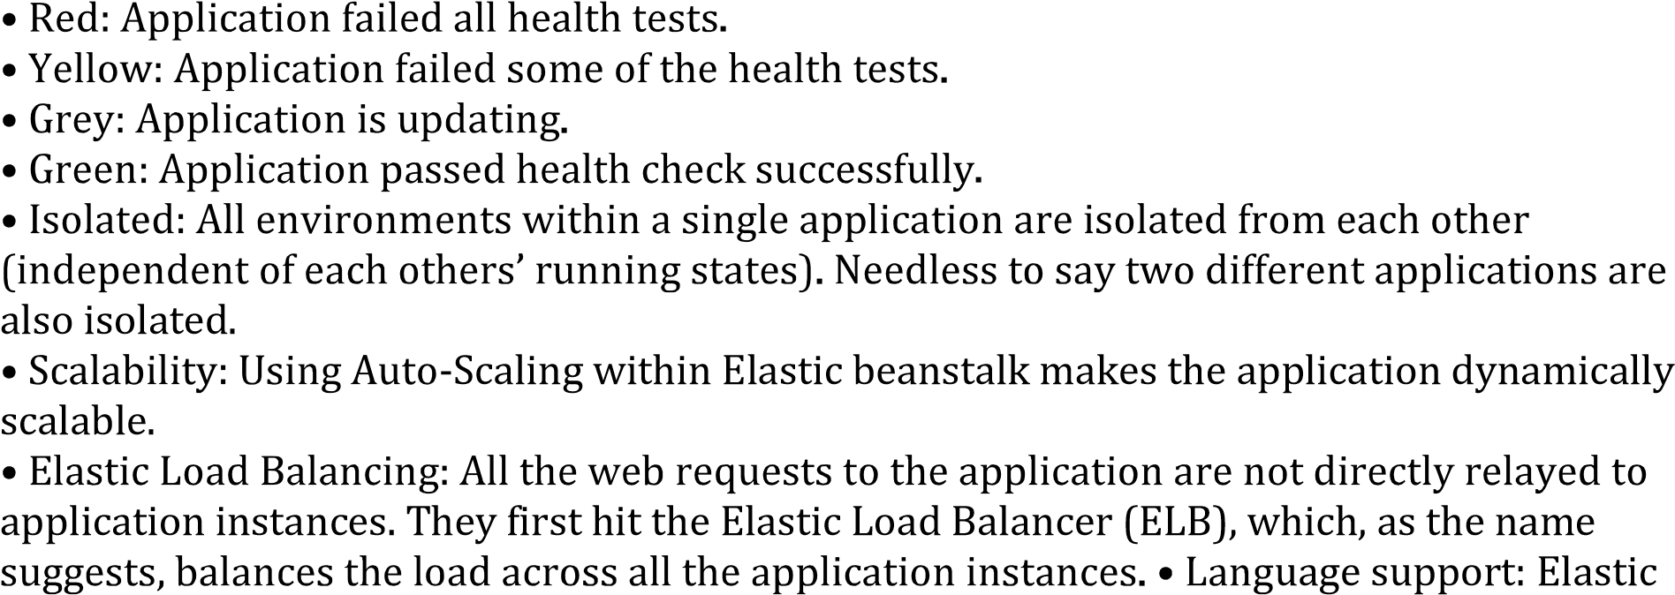
Beanstalk supports the applications developed with Java, .NET, PHP, Node.js, Python, Ruby, Go, and Docker on familiar servers such as Apache, Nginx, Passenger, and IIS.
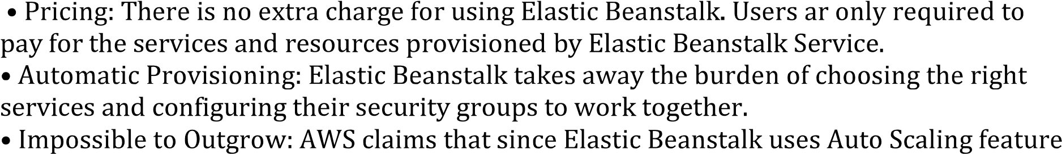
it can, in theory, handle any amount of internet traffic

B.2 Conclusion:
(Students must write the conclusion as per the attainment of individual outcome listed above and learning/observation)
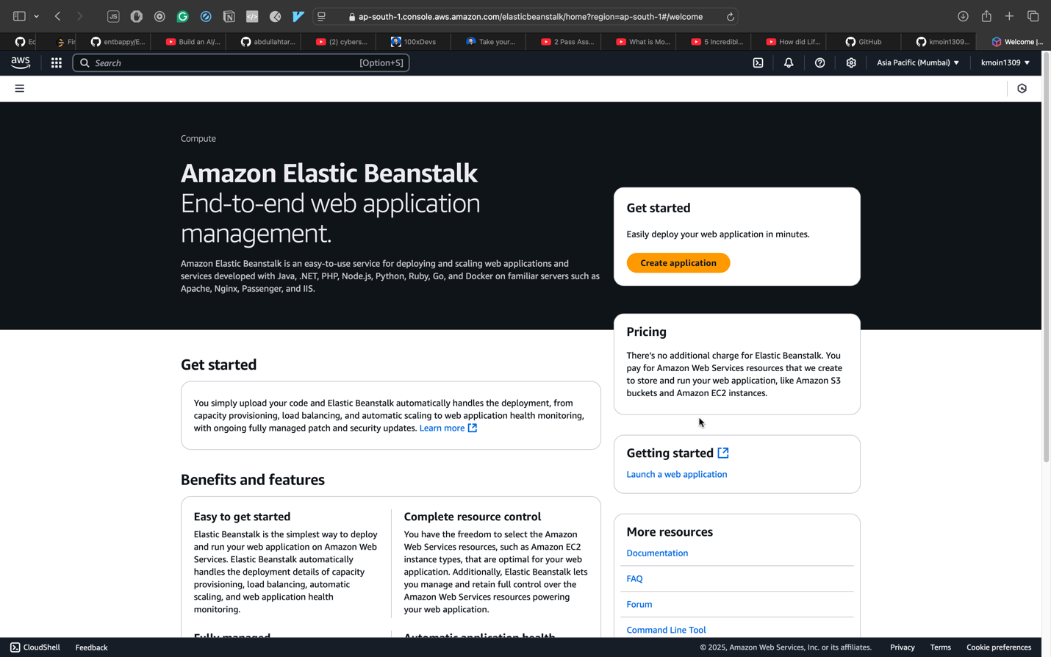
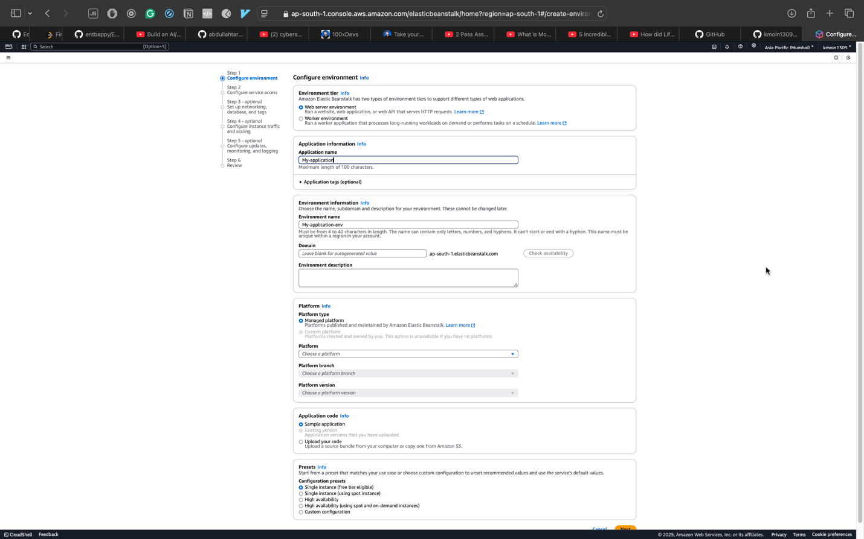
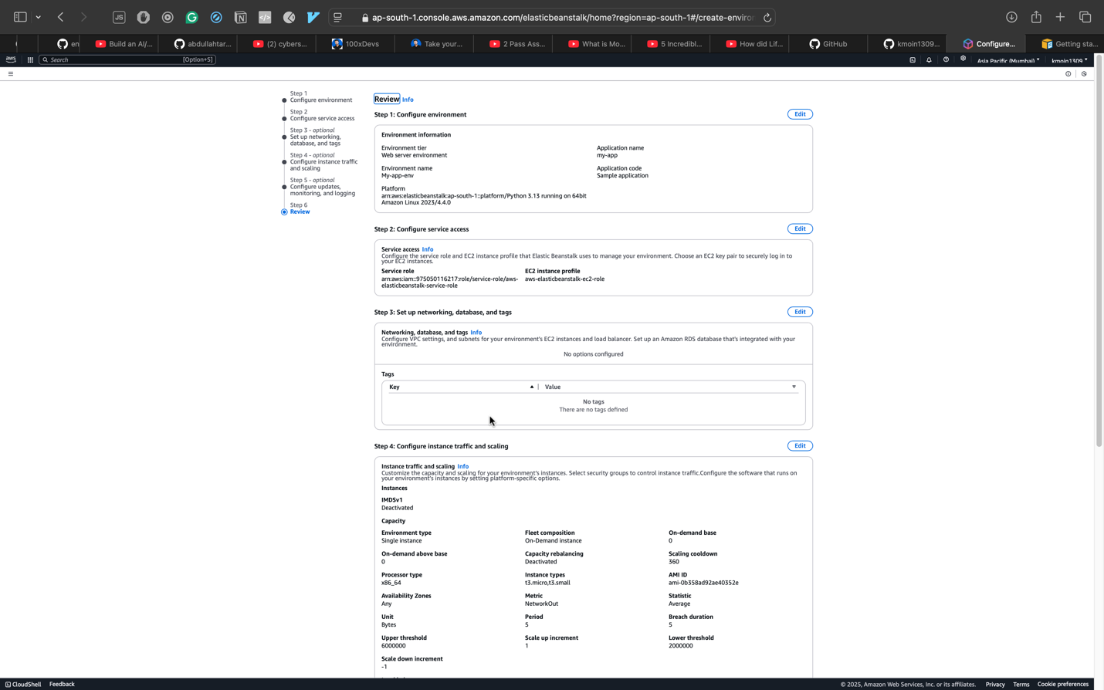

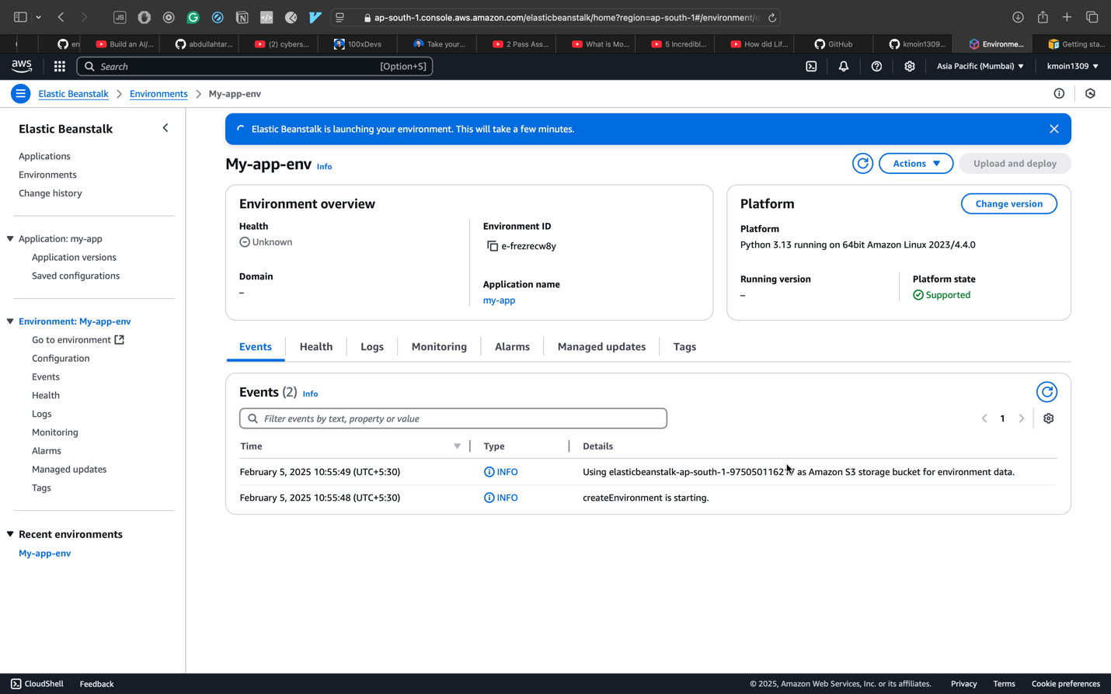

In conclusion, the practical deployment of a web application using AWS Elastic Beanstalk demonstrated the platform's user-friendly approach, automatic scaling, and support for diverse programming languages. Students gained hands-on experience in deploying, monitoring, and managing applications in a Platform as a Service (PaaS) environment.

